18.62: If the original height is h and the piston descends a distance y, the final pressure of the air will be 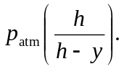 This must be the same as the pressure at the bottom of the mercury column, 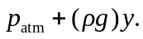 Equating these two, performing some minor algebra and solving for y gives

